Experimental Investigation of the Effect of Tilt and Orientation Angles on the Performance of Photovoltaic Cells

El Tantawy. H. Y¹, Abdellatif, O. E¹, Elmahallawi, I. S², Assassa, G., M¹. and, Abd Rabbo, M¹.

¹ Faculty of Engineering-Shoubra –Mechanical Engineering department Benha University
² Faculty of Engineering- Cairo University
Abstract
Photovoltaic (PV) systems are among the most important renewable energy sources that can satisfy the world’s energy requirements. Performance of PV solar module is affected by its orientation and its tilt angles with horizontal plane. These two parameters change the amount of solar energy received by the surface of the PV module. In this study, we show the optimum tilt angle and orientation of a solar photovoltaic panel that generates the greatest registered value for electrical energy. Experiments are evaluated during the winter period (from January till April) in the location of measurements (Shoubra, Cairo, Egypt, Latitude 30° 5' 6N and longitude 31° 14' 19E). The first experimental work when solar modules oriented towards South-East, South, South-West, the module oriented towards the South 45° gives the greatest values of electrical energy for all the chosen angles. The second experimental work when solar modules oriented towards south, south+15°, south-5°, south-10° and south-15°, the module oriented towards the South-10° for the angle of 45° gives the greatest values of electrical energy for all the chosen angles. From the observation data we obtained in our research we recommend that, the best orientation for solar modules in Shoubra, Cairo, during the winter period, is toward the South-10° installed at an angle of 45° that is latitude + 15°.
1. Introduction
The amount of solar energy incident on a solar collector in various time scales is a complex function of many factors including the local radiation climatology, the orientation and tilt of the exposed collector surface. The performance of PV module is highly influenced by its orientation and its angle of tilt with the horizon. This is due to the fact that both the orientation and tilt angle change the solar radiation reaching the surface of the PV collector. It is necessary to calculate the optimum tilt angle which maximizes the amount of collected energy. It is generally known that in the northern hemisphere, the optimum collector orientations south facing and that the optimum tilt depends on the latitude and the day of the year [1]. In winter months, the optimum tilt is greater (usually latitude +15°); whilst in summer months the optimum tilt is lower (usually latitude -15°). Egypt is in advantageous position with solar energy, located in northern hemisphere. In 1991 solar atlas for Egypt was issued indicating that the country enjoy 2900-3200 hours of sunshine annually with annual direct normal energy density 1970-3200 kWh/m2[2]. These data show that solar energy could be used for certain applications espial photovoltaic cells, solar water heating and solar thermal power. In Egypt PV systems are considered one of the most appropriate applications for remote areas away from national grid. Therefore, the goal of this study was to determine optimum panel tilt angle, the orientation and to investigate the effects of panel tilt angles and the orientation on the amount of solar radiation received by a PV panel and the power generation.

2. LITERATURE SURVEY
There are various devices for absorbing the solar radiation. The Sun rays are to be always focused on to the absorber plate. The collector has to be rotated by tracking system, but the tracking system is very costly so we cannot use this for every system economically. Due to this reason the solar collector is fixed either monthly, seasonally or yearly pattern, based on our requirements. There are many papers in the literature which make different recommendations for the optimum tilt, based only on the latitude [3]. In practice, a collector plate is usually oriented South facing and at a fixed tilt which is set to maximize the average energy collected over the year. Orientation of the collector is described by its azimuth and tilt angles. Generally, systems installed in the northern hemisphere are oriented toward southland tilted at a certain angle [4]. Many investigations have been carried out to determine the best tilt angle for such systems. For example, φ +20°[5], φ +10°[6],φ-10°[7], whereas some researchers suggest two values for the tilt angle, one for summer and the other for winter, such as φ±20° [8], φ±8° [9], φ±5° [10],where φ is the latitude, “+” for winter, and “−“ for summer. Sakonidou E.P. et. al. [11] developed a mathematical model. The model starts by calculating the hourly solar irradiation components (direct, diffuse, and ground-reflected) absorbed by the solar chimney of varying tilt and height for a given time (day of the year, hour) and place (latitude). Moghadam Hamid .et. al. [12] estimated solar global radiation on a horizontal surface using a mathematical model and the results were compared. Ibrahim D. [1] examined for selection of optimum tilt angle of Cyprus. For maximum radiation the results were calculated by varying tilt angle form 0° to 90° with the increment of 10°.
John Kaldelliset.al. [13] Experimental study is currently carried out in the area of Athens, in order to evaluate the performance of different PV panel tilt angles during the summer period. According to the experimental results obtained, the angle of 15 (±2.5°) is designated as optimum for almost the entire summer period. Amit Kumar Yadav, S. SChandel [14] shows that for maximum energy gain, the optimum tilt angle for solar systems must be determined accurately for each location.Yong Sheng Khoo. et.al. [15] modeled results are compared with measured values from irradiance sensors facing 60° NE, tilted at 10°, 20°, 30°, 40°, and vertically tilted irradiance sensors facing north, south, east, and west in Singapore. Using the Perez model, it is found that a module facing east gives the maximum annual tilted irradiation for Singapore's climatic conditions. These findings are further validated by one-year comprehensive monitoring of four PV systems (tilted at 10° facing north, south, east, and west) deployed in Singapore. The PV system tilted 10° facing east demonstrated the highest specific yield, with the performance ratio close to those of other orientations
3. Experimental Setup
3.1. Experimental site and PV module
The experiment was conducted on the rooftop of El-Khalafawy building located at Shoubra faculty of engineering, Benha University in Cairo, Egypt, situated at the 30.07 Latitude and 31.2 Longitude, with moderate and continental climate. Egypt has yearly average of 289 sunny days and yearly average total sunshine duration of 2900-3200 h [2].
A IS4000P Series, with poly crystal silicon solar cells, with dimensions 675×1490×42 mm, with maximum power 150 W, for the normal solar radiation intake intensity of 1000 W/m², at temperature T = 25°C, was used in the experiment, as shown in Figure 1.
The aim of the experiment was to determine the amount of electrical energy generated by solar - module as a facade element in relation to its tilt angle and orientation.
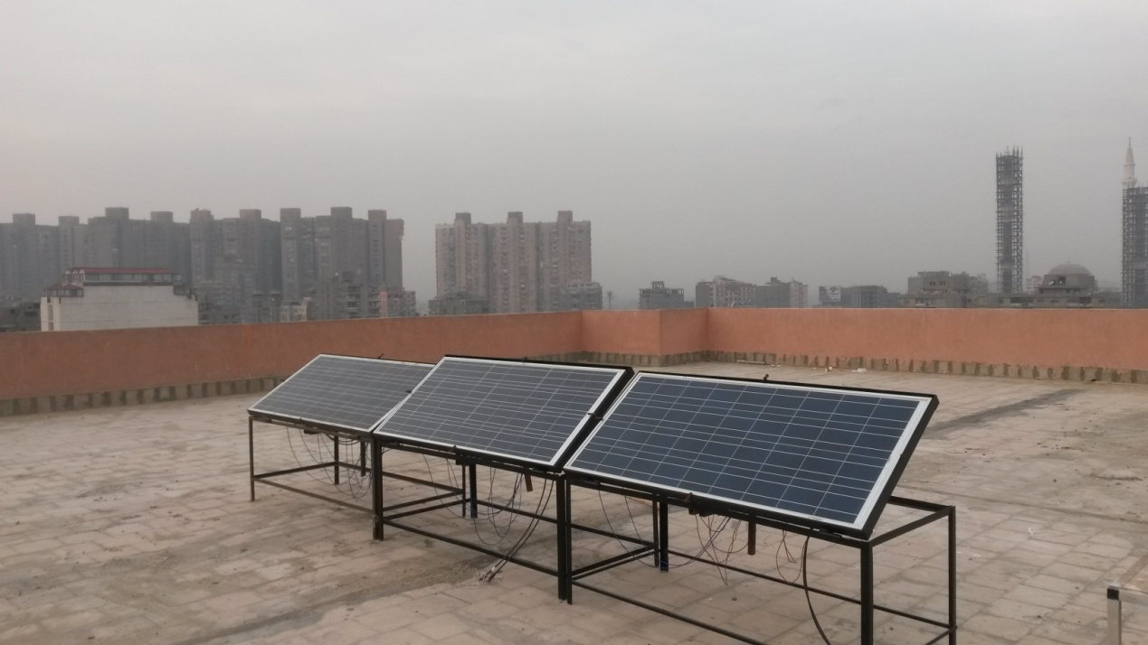
Figure1. Solar module, A IS4000P Series, on adjusted stand

3.2. Measuring system
The data is collected daily at an interval of every thirty minutes, from 8 am until 5 pm. During the operation, solar radiation is measured by using a digital solar power meter, which is put at the same level as the solar panels. The PV current and PV voltage are collected during the operation of system to calculate the power output from the PV modules.
A scheme of rotational solar module on a movable stand is shown in Fig.2.
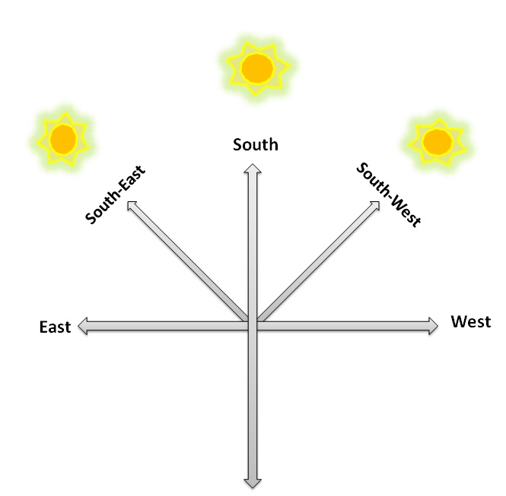
Figure 2. A scheme of different orientations of solar module
Solar module was installed on the movable stand, which enables changing of the position of the solar module from south- east to south- west. By means of suitable mechanism a position of solar module can be changed around the axis in relation to horizontal plane for the angle β (from 0° to 90°) as shown in Fig. 3.
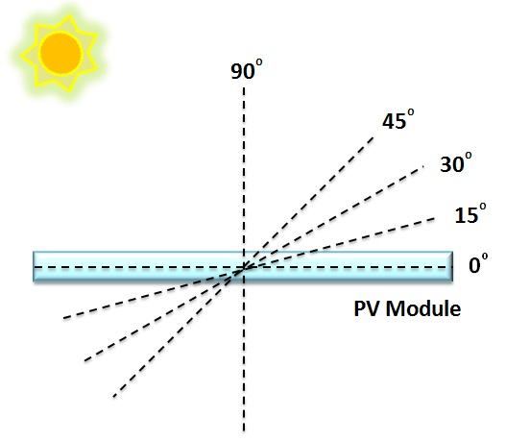
Figure 3. Position of solar module for chosen angles for which current/voltage characteristics and solar radiation intensity were measured
In this experiment the rotational solar module was positioned in the predefined angles. On each full hour, from 8am till 5pm, the solar module was rotated towards the South- East, South and South- West and positioned for the angles 0^{ᴼ}, 15^{ᴼ}, 30^{ᴼ}, 45^{ᴼ} and 90^{ᴼ}. In these positions the values for current, voltage, power and solar radiation intensity were measured.

4. Results and Discussions.
Changes in obtained electrical energy during the day, depending on the position of solar module in relation to horizontal plane (angle β), for all the above mentioned angles, for the South-East, South and South-West are shown in figures 4, 5 and 6 respectively.

Figure 4Change in the obtained electrical energy during the day, depending on the position of the solar module in relation to horizontal plane (angle β) for the South-East

Figure 5 Change in the obtained electrical energy during the day, depending on the position of the solar module in relation to horizontal plane (angle β) for the South

Figure 6Change in the obtained electrical energy during the day, depending on the position of the solar module in relation to horizontal plane (angle β) for the South South-west

Values of generated electrical energy for the chosen angles and positions are given in table 1 .Based on Fig. 4, 5 and 6 and Table 1 it can be seen that the solar module oriented towards the South-West at an angle of 45^{ᴼ} generates electrical energy of 1680.613Wh, which is minimal electrical energy for the South-West. Solar module oriented towards the South gives the greatest value for electrical energy for the angle of 45^{ᴼ} of 1961.912 Wh, which is the maximum registered value for electrical energy.
It is visible from Table 1 that for fixed angles of 0^{ᴼ}, 15^{ᴼ}, 30^{ᴼ}, 45^{ᴼ} and 90^{ᴼ}solar module oriented towards the South gives the greatest values of electrical energy. Values of obtained electrical energy for the South-West, South and South-East and positions for the angles 0°, 30°, 45°, 60° and 90°, are given in figures 7. Values of daily solar radiation intensity measured by solar power meter are given in figures 8.

Table 1. Values of generated electrical energy for the chosen angles and positions
Angle | South-West (Wh) | South (Wh) | South-East (Wh)
0^{ᴼ} | 1376.089 | 1550.818 | 1502.3
15^{ᴼ} | 1471.622 | 1522.284 | 1505.235
30^{ᴼ} | 1543.154 | 1935.565 | 1745.718
45^{ᴼ} | 1680.613 | 1961.912 | 1767.875
90^{ᴼ} | 1380.447 | 1651.341 | 1363.748

Figure 7. Values of obtained electrical energy, for the south- West, South and south- East for all chosen angles

Figure 8. Values of daily solar radiation intensity measured by solar power meter, for the south- West, South and south- East for all chosen angles

Form the first experiment, it is noticed that, solar module oriented towards the South gives the greatest value for electrical energy so the South is compared with new orientations with different Surface Azimuth Angle, γ (south+15°, south-5°, south-10° and south-15°) as shown in figure 9 to find the best orientation that gives the greatest values of electrical energy. Values of obtained electrical energy for new orientations and positions for the angles 0°, 30°, 45°, 60° and 90°, are given in figures 10,11,12,13 and 14.
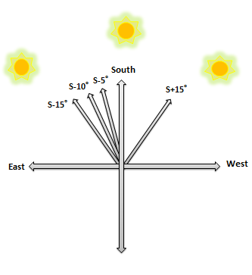
Figure 9. A scheme of different orientations of solar module

Figure 10 Change in the obtained electrical energy during the day, depending on the position of the solar module in relation to horizontal plane (angle β) for the South+15⁰

Figure 11 Change in the obtained electrical energy during the day, depending on the position of the solar module in relation to horizontal plane (angle β) for the South

Figure 12Change in the obtained electrical energy during the day, depending on the position of the solar module in relation to horizontal plane (angle β) for the South-5⁰

Figure 13 Change in the obtained electrical energy during the day, depending on the position of the solar module in relation to horizontal plane (angle β) for the South-10⁰

Figure 14 Change in the obtained electrical energy during the day, depending on the position of the solar module in relation to horizontal plane (angle β) for the South-15⁰

Values of generated electrical energy for the chosen angles and positions are given in table 2 .Based on Figs. 11, 12, 13, 14 and 15 and Table 2 it can be seen that, the solar module oriented towards the South-10° gives the greatest value for electrical energy for the angle of 45^{ᴼ} of 1944.752 Wh, which is the maximum registered value for electrical energy.
Values of obtained electrical energy for the South+15°, South, South-5°, South-10° and South-15° and positions for the angles 0°, 30°, 45°, 60° and 90°, are given in figures 15. Values of daily solar radiation intensity measured by solar power meter are given in figures 16.
Angle | South+15° | South | South-5° | South-10° | South-15°
0^{ᴼ} | 1541.735 | 1594.019 | 1674.765 | 1747.641 | 1684.222
15^{ᴼ} | 1484.857 | 1495.218 | 1551.218 | 1755.819 | 1619.253
30^{ᴼ} | 1659.486 | 1673.082 | 1797.046 | 1931.094 | 1847.082
45^{ᴼ} | 1807.974 | 1812.941 | 1902.575 | 1944.752 | 1909.811
90^{ᴼ} | 1638.609 | 1653.078 | 1753.078 | 1806.148 | 1701.338

Table 2. Values of generated electrical energy for the chosen angles and positions

Figure 15. Values of obtained electrical energy for the South+15°, South, South-5°, South-10° and South-15° and positions for the angles 0°, 30°, 45°, 60° and 90°

Figure 16. Values of daily solar radiation intensity measured by solar power meter for the South+15°, South, South-5°, South-10° and South-15° and positions for the angles 0°, 30°, 45°, 60° and 90°

5. Conclusion
On the basis of the above mentioned one can conclude that:
- For the first experimental work when solar modules oriented towards South-East, South, South-West, the module oriented towards the South gives the greatest values of electrical energy for all the chosen angles.
- Solar module oriented towards the South for the angle of 45^{ᴼ}generates the greatest registered value for electrical energy.
- Generated electrical energy for solar module oriented towards the South 45° and South 30° differ by 1.34%.
- For the second experimental work when solar modules oriented towards south, south+15°, south-5°, south-10° and south-15°, the module oriented towards the South-10° gives the greatest values of electrical energy for all the chosen angles.
- Solar module oriented towards the South-10° for the angle of 45^{ᴼ}generates the greatest registered value for electrical energy.
- Generated electrical energy for solar module is directly proportional to solar radiation.
- The best orientation for solar modules in Cairo, during the winter period, is toward the South-10° installed at an angle (β) of 45°. That is latitude + 15°.

REFERENCES
[1]  [2] | D. Ibrahim, Optimum tilt angle for solar collectors used in Cyprus, Renewable Energy 6, 7 (1995) 813−19.  D. Loy: Energy policy framework conditions for electricity market and renewable energies.Country analyses, chapter Egypt, GTZ, GmbH, 2007.
[3] | M. Iqbal, Optimum collector slope for residential heating in adverse climates. Solar Energy 22 (1979) 77−9.
[4] | A. M. Shariah, A. Al-Akhars, I. A. Al-Omari, Optimizing the tilt angle of solar collectors, Renewable Energy 26 (2002) 587−98.
[5] | H. C. Hottel, Performance of flat-plate energy collectors. In: Space Heating with Solar Energy, Proc. Course Symp. Cambridge: MIT Press, 1954.
[6] | J. Kern and L. Harris, On the optimum tilt of a solar collector. Solar Energy (1975) 17.97.
[7] | H. Hyewood, Operating experience with solar water heating. Journal of the Institution of Heating and Ventilation Engineers 39 (1971) 63−9.
[8] | H. Yellott, Utilization of sun and sky radiation for heating cooling of buildings. ASHRAE Journal15 (1973) 31.
[9] | G. Lewis, Optimum tilt of solar collectors. Solar and Wind Technology 4 (1987) 407.
[10] | H. P. Garp, G. L. Gupta. In: Proceedings of the International Solar Energy Society, Congress, New Delhi 1978, 1134.
[11]  [12]  [13]  [14]  [15] | Sakonidou E.P., Karapantsios T.D., Balouktsis A.I. and Chassapis  D.,―Modeling of the optimum tilt of a solar chimney for maximum  air flow‖, Solar Energy, 2008; 82: 80–94.Moghadam Hamid, Farshchi T. F. and Sharak A. Z., ―Optimization of solar  flat collector inclination‖, Desalination, 2011; 265: 107–111.  John Kaldellis*, Dimitrios Zafirakis “Experimental investigation of the optimum photovoltaic panels’ tiltangle during the summer period” Energy 38 (2012) 305-314  Amit Kumar Yadav, S. S. Chandel “Tilt Angle optimization to maximize incident solar radiation: are view” Renewable and Sustainable Energy Reviews  23(2013)503-513  Yong Sheng Khoo, Andr´e Nobre, Raghav Malhotra,Dazhi Yang, ThomasReindl, and Armin G. Aberle“Optimal Orientation and Tilt Angle for Maximizing in-Plane Solar Irradiation for PV Applications in Singapore” IEEE JOURNAL OF PHOTOVOLTAICS,VOL. 4, NO. 2, MARCH 2014

